Celtia

**The Battle of Moytura**

**Design Document**

Craig Foucher

CIS 487

Dr. Maxim

Due 12/17/02

# Overview

Celtia is an action/roleplaying game with a mythological storyline. The player controls Lugh, a mythical warrior god from ancient Ireland. His task is to rid Ireland of the race of giants, the Fir Bolg, and the race of monsters, the Fomorians.

The players main task is to navigate Lugh through the game world and defeat the enemies that he encounters. When Lugh or an enemy is defeated he disappears. There is minimal violence and gore contained in this game.

Celtia offers a challenge to the player in that the player must defeat the main boss enemies in a particular order to win the game. The game is also easy to play with simple controls. There is one button to attack enemies, four buttons to move in different directions, and a button to quit the game.

The setting of Celtia is ancient Ireland. It is the great Battle of Moytura in which Lugh the warrior god defeats the Fir Bolg and the Fomorians in order to bring humanity to the world. This is the legend that is the bases for the Irish creation story. The game starts with Lugh on the shores of Ireland. He has just arrived from the lands in the north. No one knows where from exactly though. He is trained in the occult arts and many trades. He brings with him his mighty spear to banish the enemy creatures to the underworld.

This game would theoretically appeal to people of all ages. It is easy to play and contains very minimal gore and violence.

# Game Mechanics

## Overview

Celtia is a 2D third person game in the vein of The Legend of Zelda and Dungeons and Dragons Warriors of the Eternal Sun. Players of these games will surely enjoy the look and feel of Celtia.

## Camera Position

In Celtia, the player will control character Lugh. The player can move Lugh across the screen. When Lugh reaches the edge of the screen the screen scrolls to another part of the game world and Lugh starts at the opposite edge of the screen from the previous screen. The camera is always looking at Lugh and the game world as a partial birds-eye view.

## User Interface Design

The majority of the player's screen will be taken up by the game world view. The is also a black area along the top of the screen that is approximately one hundred pixels in height. This area displays the following information:

* **Lugh's Hit Points:** This is the amount of life that Lugh has. If it falls to zero or below zero Lugh dies, and the player loses the game.
* **Minions Killed:** This is the count of how many minor enemies that the player has killed in the game so far.
* **Bosses Killed:** This is the count of how many major enemies that player has defeated in the game so far. If the player defeats all the bosses they win the game.

## Replaying and Saving

There are no number of "lives" in Celtia. Once the player's hit points fall to or below zero, they lose the game. If this happens the player must restart the game and start from the beginning again. There is no save option as of yet implemented in Celtia.

## Control Summary

The player will use only a limited number of controls to maneuver Lugh throughout the game world. These controls are as follows:

* **Up, Down, Left, Right Arrows:** The player uses these controls to move Lugh across the screen.
* **Attack (Space Bar):** The player uses the space bar to make Lugh thrust with his spear. If he hits an enemy while attacking the enemy takes damage points off of its hit points.
* **Exit (Esc Key):** The Escape key is used to quit the game.

## Game Play Details

In Celtia the player must make Lugh attack enemies in order to defeat them. If Lugh comes into contact with an enemy and is not attacking, he will take damage points off of his hit points. If Lugh's hit points fall to or below zero he dies and the player loses the game.

The player must find the main boss lairs in a particular order. If the lair is found out of order the boss for that lair will not be there. Once all of the bosses have been found and defeated the player wins the game.

## Cut-Scenes

There are no cut-scenes in Celtia.

## Storytelling

There are no storytelling components in Celtia. The story is only given in the documentation.

Level Summary

The levels of Celtia are as follows:

* **Main Game World:** This is the starting point of the game. It is a 5x6, 30 page world in which the player maneuvers Lugh. The player must defeat enemies and find the lairs where the bosses are located.
* **Boss Lair 1:** This lair is located in the far right area of the main game world. This is where the first boss is located, Domnann.
* **Boss Lair 2:** This is the lair where the second boss, Balor, is located. Lugh must defeat Domnann before Balor will appear in this lair.
* **Boss Lair 3:** This is the lair of Eiric, king of the Fir Bolg. Lugh must defeat Domnann and Balor before this boss will appear here. Once this boss is defeated, the player wins the game.

# Artificial Intelligence

## Enemy AI

All enemies in Celtia follow Lugh's position on the screen. They keep coming toward him until they collide with him. The algorithm for this is very simple. The x and y positions of the enemy is changed to make them closer to Lugh's x and y positions.

## Player Detection

All of the enemies use the same AI previously mentioned above. The only difference is that some enemies move faster than others. This provides somewhat of a challenge to the player.

## Motion

The motion of Lugh and the enemies of Celtia uses simple physics. Characters are moved in either the x or y directions according to controls, in the case of Lugh, and Lugh's position.

## Path Finding/Collision Detection

Both Lugh and the enemy characters in the game are not able to move over background objects such as trees, water, mountains, swamp land, a castle, rocks, etc. If the encounter one of these objects they are prevented from proceeding in their current direction.

## Special Actions

There are no special actions in Celtia.

## Combat (attack, evasion, damage)

Lugh is the only character in the game that actually attacks with an attack animation. All of the enemies just move towards Lugh and don't actually make attacking motions. If Lugh collides with an enemy he either takes damage or gives damage to the enemy. If Lugh is attacking, he gives damage. Otherwise he takes damage off of his hit points.

Non-player Characters

## Puzzles and Traps

The only puzzle in Celtia is that the player must figure out the order in which to defeat the main bosses. The player must find each lair in order and defeat the boss to win the game.

# Game Elements

## Items

Although they were originally planned, due to time constraints items were not included in Celtia.

## Character bibles

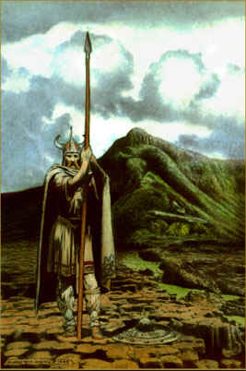 **Lugh** - son of Ethne and Cian, known as Lugh of the Long Arm. He is a skilled warrior, leader, craftsman, and sorcerer. He is well known for his deeds in battle and his skill in using his sacred spear. It is said that no battle was ever sustained against the spear. His skills are now put to the ultimate test.

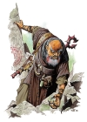 **Eochaid mac Eirc** - king of the Fir Bolg. He is a tyrannical king who reigns chaos upon the land. He awaits the hero Lugh to engage in the battle of destiny.

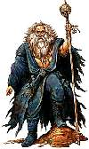 **Balor** - the evil sorcerer. His origin is unknown. He is thought to be one of the ancient sages that turned from the balance of the world and plunged himself into chaos.

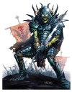 **Indech mac De Domnann** - king of the Formorians. He is a deadly fighter who is known for his terrifying skill in battle.

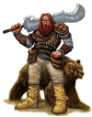 **Fir Bolg** - a race of giants that inhabit Ireland. These are the minions of Eochaid mac Eirc.

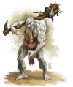 **Formorians** - a race of monster-like creatures that inhabit Ireland. They are chaotic and will attack when they wish.

# Story Overview

The story is based on an excerpt from the epic "The Battle of Moytura." This is a mythological story that is considered to be the creation story of Ireland. It describes how the Irish people came to Ireland. The story has been slightly modified for the purposes of this game.

The Tuatha de Dannan were in the northern islands of the world, studying occult lore and sorcery, druidic arts, witchcraft and magical skills, until they surpassed the sages of the pagan arts. They studied occult lore, secret knowledge and diabolic arts in four cities: Falias, Gorias, Murias, and Findias.

From Falias was brought the Stone of Fal which was located in Tara. It used to cry out beneath every king that would take Ireland. From Gorias was brought the Spear of Lugh. No battle was ever sustained against it. From Findias was brought the Sword of Nuada. No one ever escaped from it once it was drawn from its deadly sheath, and no one could resist it. From Murias was brought Dagda's cauldron. No one went away from it unsatisfied.

For many years the battles have raged on for control of these four magical items. For it is said that if a good man controls these items then peace and prosperity will come to Ireland. However, if one of evil gains these items chaos will befall the land.

The Fir Bolg control three of the magical items and the land is continually chaos and strife. Now it is up to you, Lugh son of Ethne, to use your sacred spear and retrieve the other three magical items in order to bring peace to Ireland.

## Background/Plot Summary

The Tuatha de Dannan were in the northern islands of the world, studying occult lore and sorcery, druidic arts, witchcraft and magical skills, until they surpassed the sages of the pagan arts. They studied occult lore, secret knowledge and diabolic arts in four cities: Falias, Gorias, Murias, and Findias.

From Falias was brought the Stone of Fal which was located in Tara. It used to cry out beneath every king that would take Ireland. From Gorias was brought the Spear of Lugh. No battle was ever sustained against it. From Findias was brought the Sword of Nuada. No one ever escaped from it once it was drawn from its deadly sheath, and no one could resist it. From Murias was brought Dagda's cauldron. No one went away from it unsatisfied.

For many years the battles have raged on for control of these four magical items. For it is said that if a good man controls these items then peace and prosperity will come to Ireland. However, if one of evil gains these items chaos will befall the land.

The Fir Bolg control three of the magical items and the land is continually chaos and strife. Now it is up to you, Lugh son of Ethne, to use your sacred spear and retrieve the other three magical items in order to bring peace to Ireland.

## Storyboard

### The Fomorians and the Fir Bolg

The Formorians and the Fir Bolg inhabit Ireland. Chaos overwhelms the land.

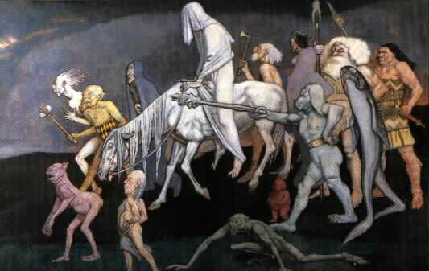

### Lugh's Arrival

Lugh arrives to bring peace and order to Ireland. He brings with him his sacred spear.

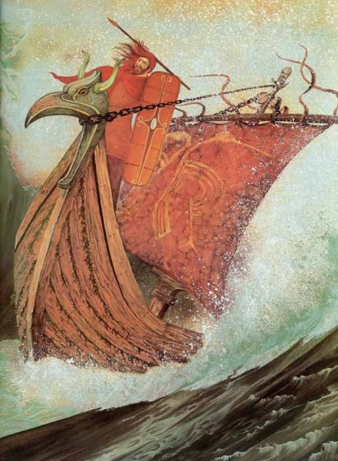

### The Battle for Ireland

Lugh battles the Formorians and the Fir Bolg to bring balance to the land.

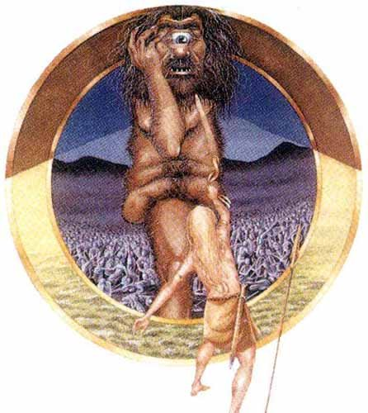

# Game Progression

## Setting

The game takes place in mythical ancient Ireland. The race of giants, the Fir Bolg, and the race of monsters, the Fomorians, inhabit the island. Lugh is the great warrior god of the Tuatha De Dannan and he must rid Ireland of these creatures.

## Introduction

The player controls the character Lugh. Lugh arrives in Ireland to rid it of the evil menace of the Fir Bolg and Fomorians. Lugh is a Tuatha De Dannan a spiritual race of beings that are skilled in the occult arts and trades.

## Flowchart



## Level and Scene Details

The levels of Celtia consist of a main world and four sub-worlds or levels. Each sub-world contains a main boss that Lugh must defeat in order to gain a magical item and therefore advance to the next sub-world. Due to constraints on time for this project, these sublevels may not be fully implemented. It may be the case that these sublevels are no more than one or two room battle areas. They may be expanded at a later date.

### Main World

The main world is where the player starts the game. It contains a forest, swamp, standing stone circle, mountains, and a castle. There are Fir Bolg and Formorian enemies and special items founds throughout the main world. There are also access points to sub-worlds in the different areas. See Figure 2 attached to this document.

### Boss Lair 1

Boss Lair 1 is located in the mountains in the far right area of the main game world. This is where the player must defeat Domnann, the king of the Fomorians.

### Boss Lair 2

Boss Lair 2 is located in an ancient tree in the top left corner of the main game world map. This is where Balor, the evil sorcerer, is located. Lugh must defeat Domnann before being able to confront this enemy.

### Boss Lair 3

Boss Lair 3 is located in a castle in the top part of the main game world map. This is where Eiric, the king of the Fir Bolg, is located. Lugh must defeat Domnann and Balor before being able to confront this enemy.

# Bibliography

Rouse, Richard III. Game Design Theory and Practice. Wordware Publishing Inc., Plano, Texas, 2001.

LaMothe, Andre. Tricks of the Windows Game Programming Gurus. Sams Publishing, Indianapolis, Indiana, 2002.